# Project – Refactor Udagram app into Microservices and Deploy

**Travis CI Build Command**

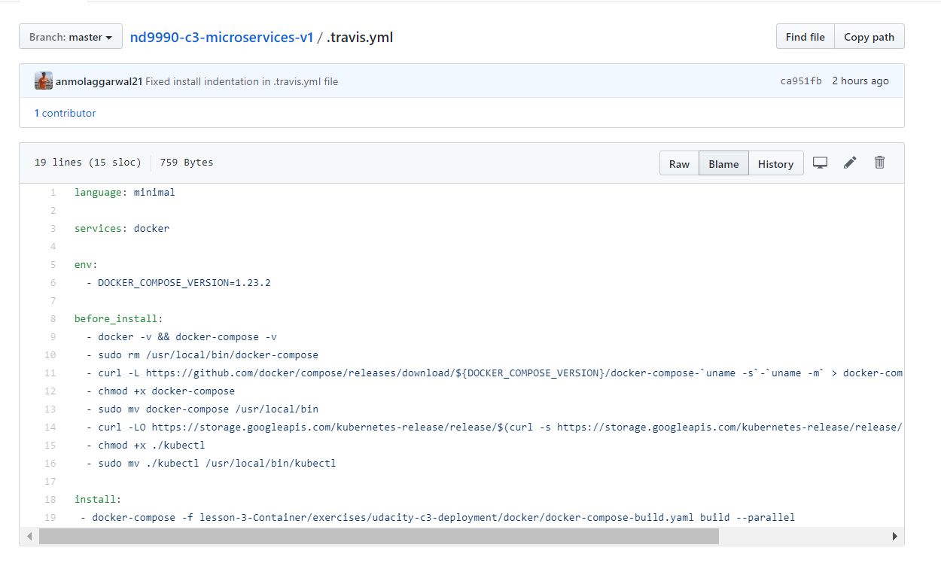

**Travis Ci Build Successful**

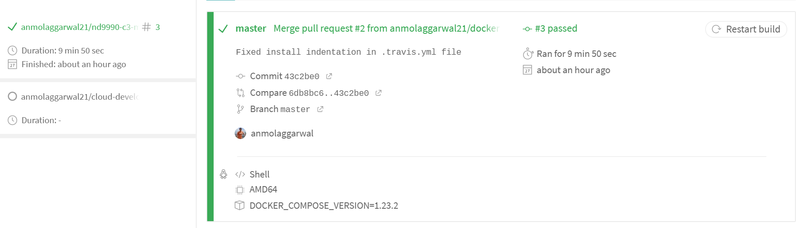

Public Git hub Repository

<https://github.com/anmolaggarwal21/nd9990-c3-microservices-v1>

**Docker Images**

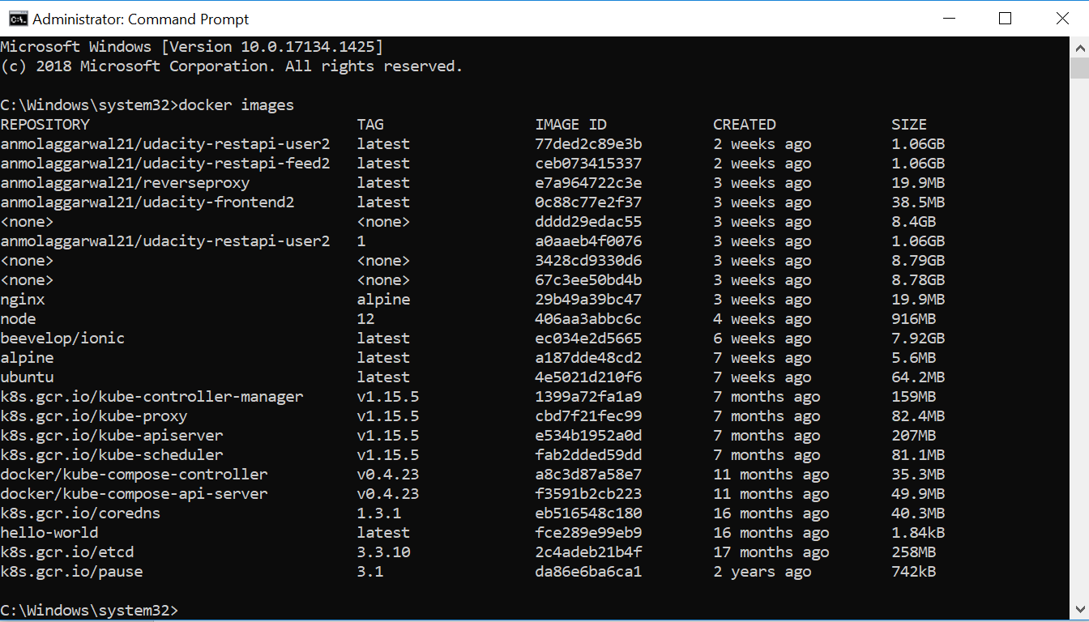

**Docker Container**

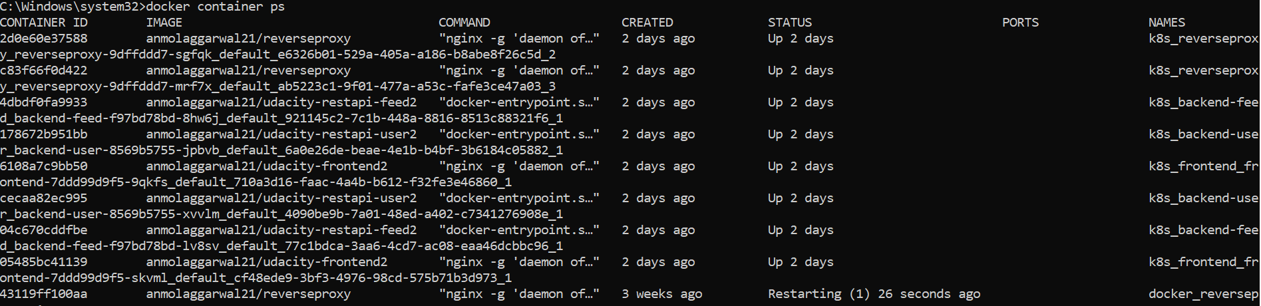

**Kubectl Pods**

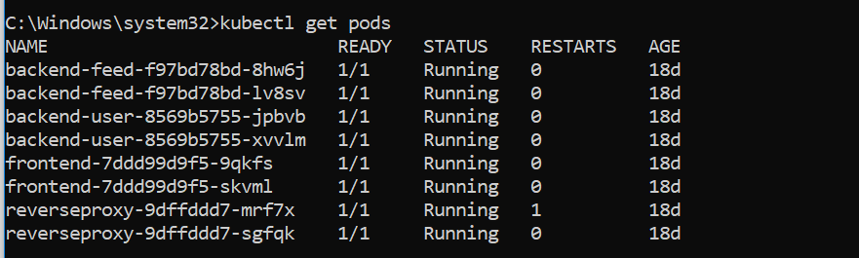

**Kubectl Services**

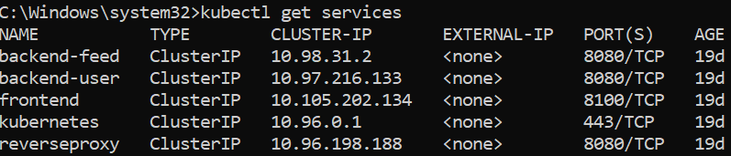

**Kubectl get secrets**

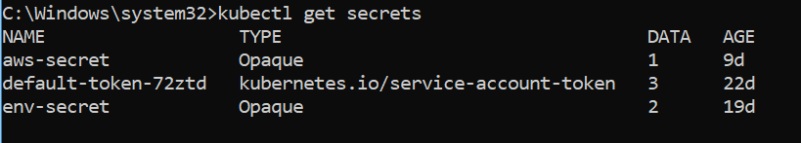

**Kubectl port forwarding**



Able to get the image Title along with the images

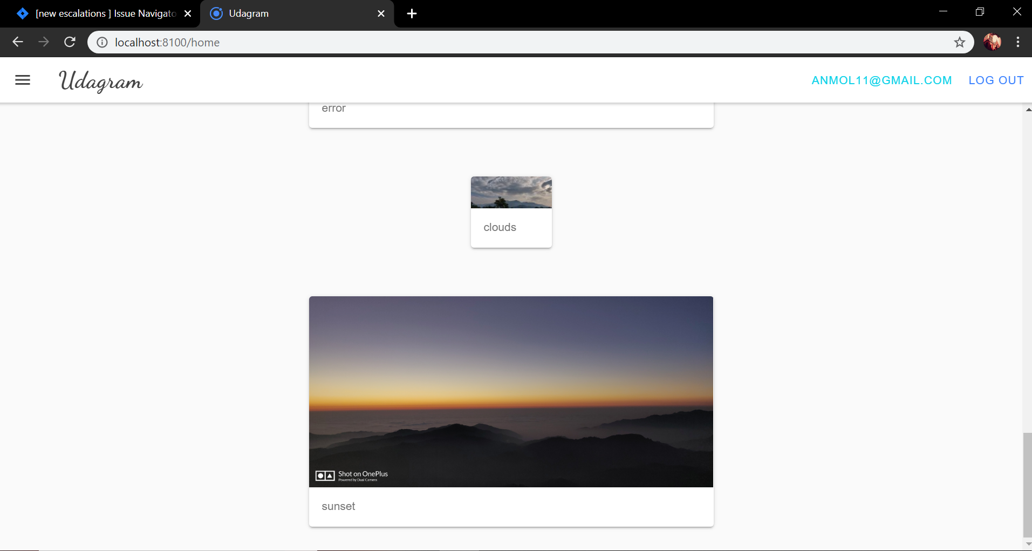

New Post

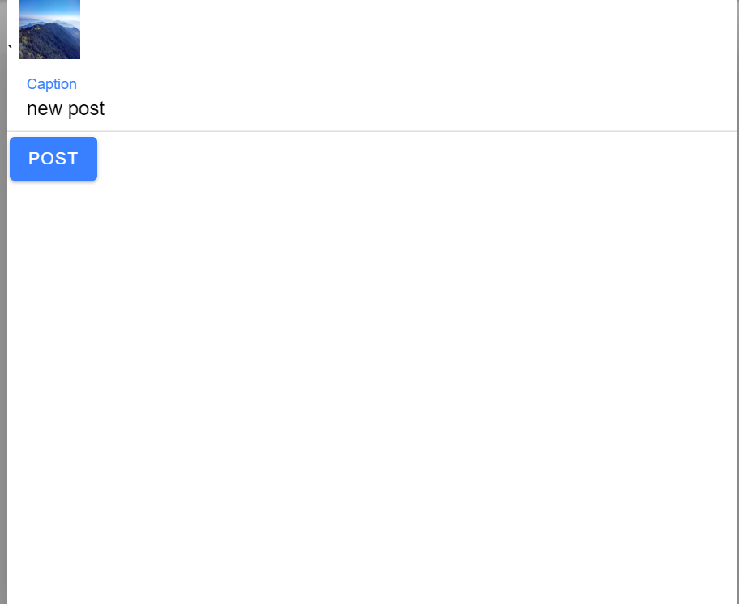

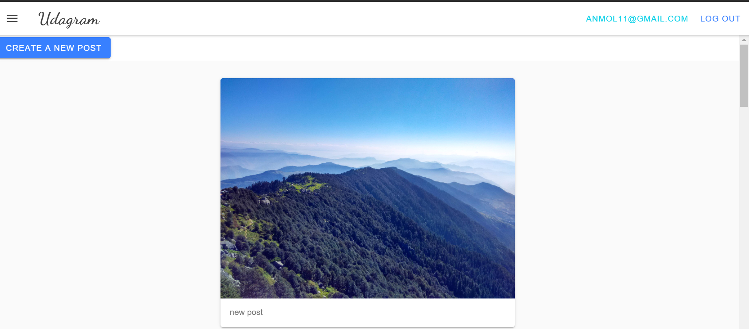

**Details**

**The main code in the lesson -3 Container . I have implemented the docker images and the K8 code inside the mentioned folder. We have the docker file there, docker compose file , docker compose build file. Along with this the K8 respective yaml files are also present there**